Design Specification

Oracle Consulting Services

P20 Generic LDAP

Author: Dieter Steding
Creation: Date: 06/29/2023
Latest Update: 07/02/2023
Control Number: <Document Control Number>
Version: 1.0.0.0

Approval:

Document Control

Change Record
Date | Author | Version | Change Reference
06/29/23 | Dieter Steding | 1.0.0.0 |  | No previous document

Reviewer
Name | Position

Distribution
Copy No. | Name | Location
1 | Library Master | Project Library
2 |  | Project Manager
3
4
Table of Content
Document Control ii
Change Record ii
Reviewer ii
Distribution ii

Accountability
Participants accountability includes:
The participants are able to implement the dependencies of multiple IT systems necessary for account provisioning in order to obtain the extensive use of a specialist procedure. This requires the participant is familiar with the infrastructure components involved.
Ensuring that the data provided by the F-IAM are integrated in their timely correctness.
Any violation of the consistency and integrity of the data provided will inevitably result in the rejection of the user accounts affected, regardless of the interface used for delivery.
The participants are obliged to rectify errors themselves. Full support from the operational staff of the Federal Criminal Police Office is not provided.
For a participant who decides to independently control the provisioning of the user accounts through his IAM system, any rights to a further manual assignment of rights, roles or user accounts in the central F-IAM are withdrawn (view only principle; responsibility principle).

Limits
It will not be possible to specify an initial password or change an existing one for an account due to the sensitivity of such data.
Dependencies on account are no longer applicable due to its out of control of Identity Manager what is delivered.

Provisioning Service
The Provisioning Service provides the API to trigger provisioning accounts to the target system. Therefore it is a facade on top of the core functionality Identity Manager already offers for this purpose.
The need to implement such a service arises from the distribution of the services across the participants that supply data for provisioning and the consistency and integrity of such data at the time of its delivery.
The main task of this service is therefore to protect the internal provisioning processes in Identity Manager from inconsistencies within the data delivery and to ensure the security requirements of the Federal Criminal Police Office with regard to the sensitivity of the data. At the same time, this service is responsible for communicating to the data sources provisioning orders that cannot be carried out for any reason.

Inbound Schema of the Service
The service expects a provisioning request per application systems.

Any provisioning request is base on the following schema:
TBD: Convert it to json-schema
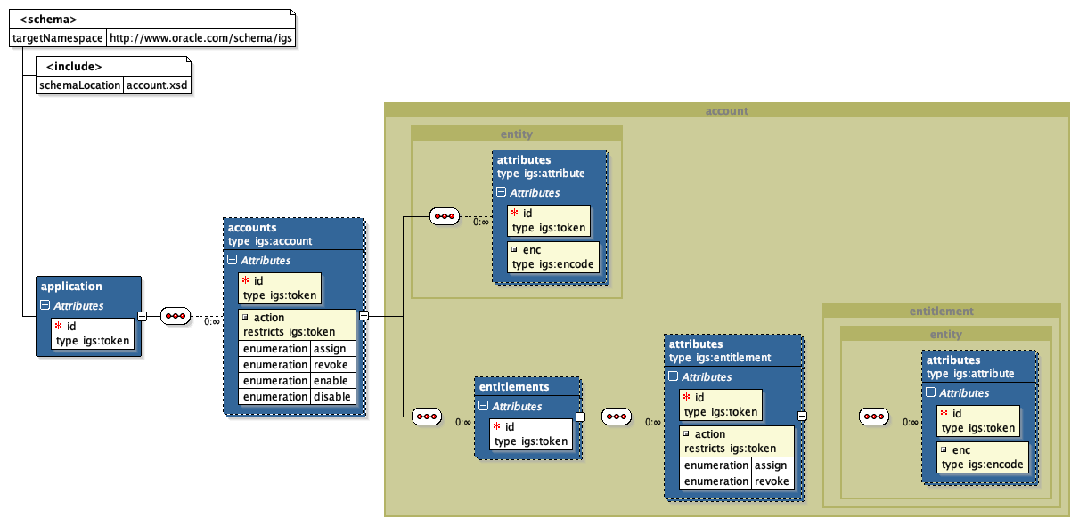

Element | Description
token | A token is a simple string with all whitespaces condensed. This means that all control characters are replaced with spaces and the resulting consecutive spaces are reduced to a single space.
encode
risk
attribute | The complex type attribute represents a tagged-value pair. An attribute carries an id for naming purpose and encloses the value mapped at that id.
entity | This type enclose the collection of generic attribute definitions.  The id attribute of this type is the public name derived from the Identity Manager configuration and intended to used for lookup any object deployed in Identity Manager by its name using the id as a matching criteria.
entitlement | The entitlement as a complex type inherits all from entity and provides as an extension the attribute action.  Attribute action on its own is an enumeration of the activities assign and revoke. Therefore it is possible to specify the activity how to handle an entitlement at the time of provisioning.
account | An account as a complex type inherits all from entity. The element entitlements of this type provides the collection of entitlements belonging to the account in the application to provision.  The type account is extended with the attribute action.  Attribute action on its own is an enumeration of the activities assign, revoke, enable and disable. Therefore it is possible to specify the activity how to handle an account at the time of provisioning.  The complex type entitlements embedded in account inherits all from entity and represents the collection of entitlements that belongs to a specific type of entitlement (OIM Child Form).
application | An application as a complex type defines the enclosing element to describe the provisioning actions on an account.  For that purpose it enclose an element accounts based on the complex type account that itselve inherits from entity. The complex type account itself enclose the complex type entitlements. To be able to specify the activities how to handle the account embedded in an application at the time of provisioning the account is extended with an attribute action. This attribute represents the regular lifecycle activities applicable on an account and enumerates assign, revoke, enable, disable. If action is unspecified its defaults to assign.  For naming purpose the application provides an attribute id that refers to the application instance name which is per definition in Identity Manager a token without any whitespace.

Interface Directory Service
The interface to the connected directory services is implemented as a background process. This process pulls out the changes made to the group assignment for an identity in an application.

Provisioning
Provisioning is triggered by the existence of a group assignment of an identity ind the group that represents an application. The changes are determined using the time stamp that each entry carries. The following rules apply:
- If the time stamp that defines the creation of the group assignment is older than the last execution date of the background process, the user account is provisioned.
- If the time stamp for creating the group assignment is unchanged, the group assignments of the authorizations are fetched, regardless of the time stamp these assignments have.
Validation
The background process skips any further action if the name of the application is not known by Identity Manager. The Provisioning Service API provides the functionality for this purpose.
The result of this discovery is pushed to the provisioning service either as a batch of accounts or as a single request per identity for validation and provisioning purpose.
The Provisioning Service API validates at first each dataset representing an account for the application. This steps includes:
Application Instance exists

Revocation
It is assumed that revocation of an account is triggered by removing an identity from the group that represents an application. Therefore this creates a huge workload due to Identity Manager has to queried for all existing accounts of an application that are tagged as primary and have any other status as revoked. This result set have than to be compared with the result set of identities that are still member of the group that represents an application.
The difference between both result sets are the accounts that have to be revoked from the application.
Any group membership on the authorization level is ignored due to it has no impact on the result. Only the Directory Service is logical inconsistence what the background process has to ignore.
For any orphaned identity detected by the comparison a revocation request is send to the Provisioning Service API.

Complex Type attribute
Namespace | http://www.oracle.com/schema/igs
Diagram
Used By
  Complex Type | entity
  Element
Attributes
  QName | Type | Use
  Id | igs:token | required
  Encode | igs:encode | optional
Source | <xsd:complexType name="attribute">  <annotation>  <documentation>  Attribute is a simple collection of tagged-value pairs.  </documentation>  </annotation>  <xsd:attribute name="id" type="igs:token" use="required"/>  <xsd:attribute name="enc" type="igs:encode" default="none"/>  </xsd:complexType>
Complex Type entity
Namespace | http://www.oracle.com/schema/igs
Diagram
Used By
  Complex Type | entity
  Element
Attributes
  QName | Type | Use
  Id | igs:token | required
  Encode | igs:encode | optional
Source | <xsd:complexType name="entity">  <annotation>  <documentation>  Entity is a generic wrapper for any object instance in Identity Manager.  Such an object instance referes to a public name of such an instance and  the internal system identifier served by Identiy Manager.  Beside those identifiers Entity specifies the attribute collection to  describe additional properties of an Entity like first name of an  account.  </documentation>  </annotation>  <xsd:sequence>  <xsd:element name="attributes" type="igs:attribute" minOccurs="0" maxOccurs="unbounded"/>  </xsd:sequence>  <xsd:attribute name="id" type="igs:token" use="required"/>  </xsd:complexType>

